Immunize Nevada COVID-19 Vaccine Outreach:
3 Million Reasons
Social Media Toolkit

SOCIAL MEDIA BEST PRACTICES
- As often as possible, post images along with text.
- Share on social platforms that are most relevant for your audience and will spark the most engagement.
- Include hashtags in your caption.
- Post at the peak times of day when you feel your audience is most active on the platform – either through analytics research, or simply based on your knowledge of when most comments tend to come in.
- Remember to encourage social sharing of personal reasons to vaccinate in order to participate in our statewide #3millionreasons outreach efforts, but do not share images that include readable vaccination cards; these cards include identifying information that can make the card-holder vulnerable to identity fraud. Encourage selfies with stickers or band-aids instead.
- As possible, share images/captions in Spanish.

HOW TO USE SOCIAL MEDIA SAMPLE POSTS
- We will be adding images and captions to this toolkit regularly, so please bookmark this page and check back for new updates.
- If you are proficient in Canva and would like the graphics shared with your Canva account, please send a request to info@immunizenevada.org. That way, you can customize graphics with your own images and text as you see fit.
- If you have another design software you prefer, such as Illustrator or InDesign, we can also package and share files with you for those as well.
- If you have a specific request — a testimonial, a powerful localized image, someone sharing their personal “reasons” — feel free to email info@immunizenevada.org, and we can create your customized graphic.
- If you’re using established graphics, download the images and copy/paste the caption from the post you’d like to share. You may personalize/make edits to copy as you see fit.
- Suggested hashtags, in addition to your brand’s hashtags: #3millionreasons, #everynevadancounts, #nvcovidfighter, #inthistogethernv #3millonesderazones (Sp)
- Direct your followers to nvcovidfighter.org for COVID-19 vaccine information.
- Graphic sizing:
  - For Facebook or Instagram, use the square graphics
  - For Twitter, use the horizontal graphics

FB/IG
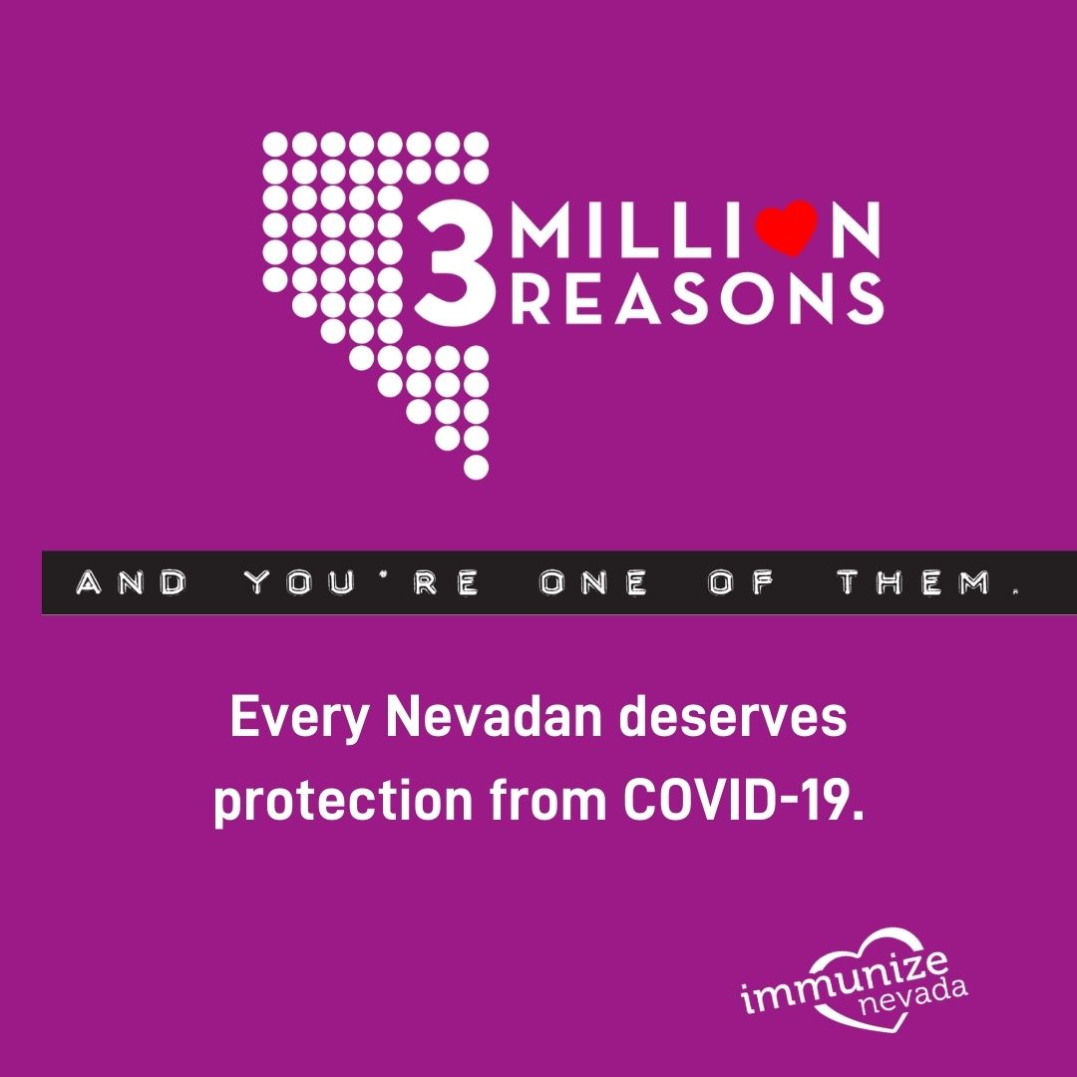

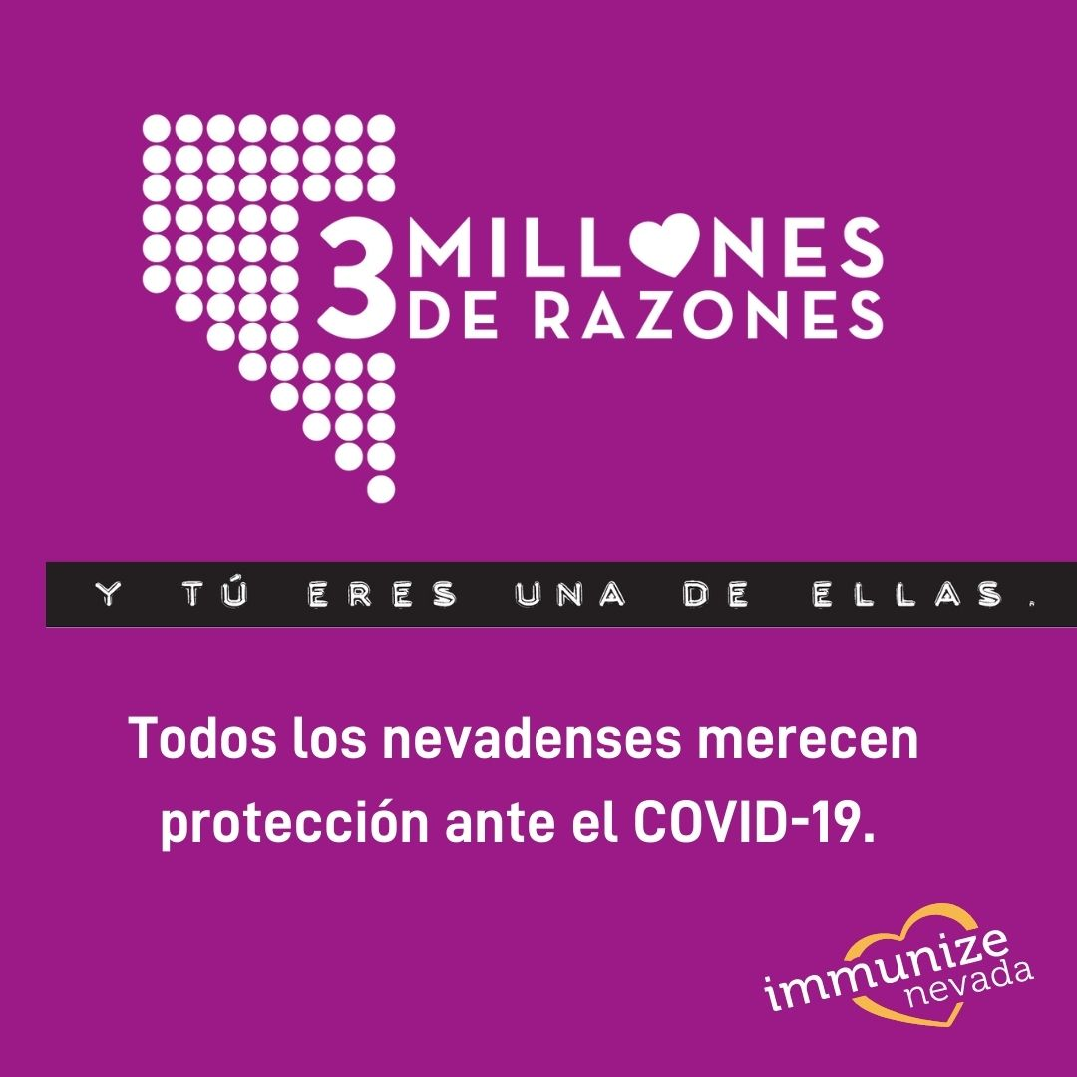

TW
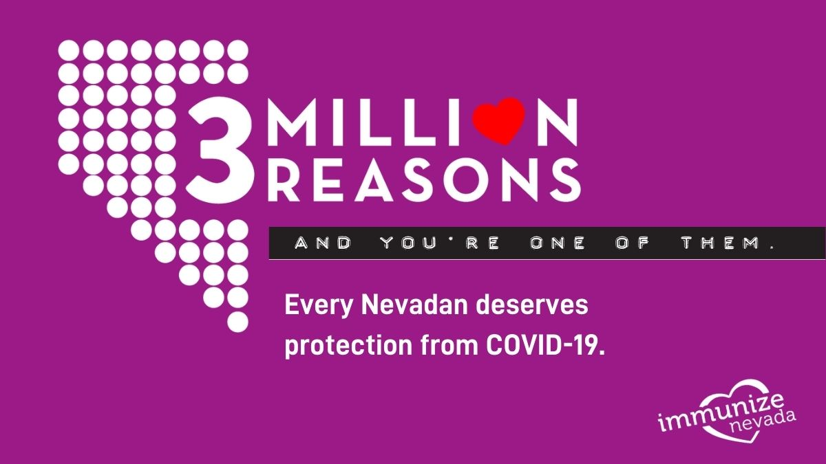

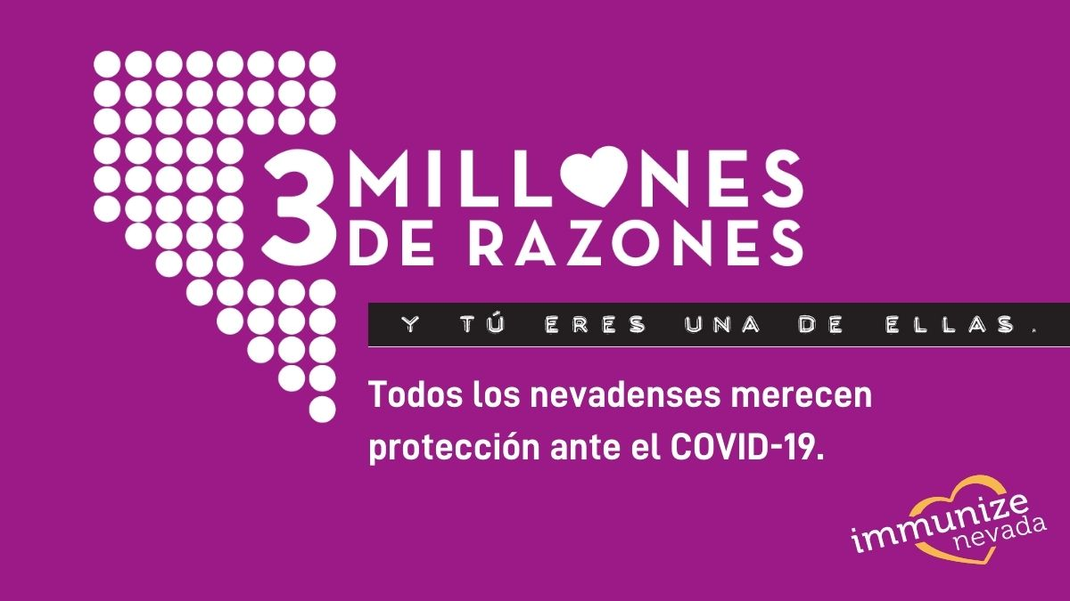

Caption:
What’s your reason for getting your COVID-19 vaccine? Whether you’re already vaccinated or eagerly awaiting your turn, post a picture using #3millionreasons, and tell us your reason. Because every Nevadan deserves protection against COVID-19, and #everynevadancounts.

¿Cuál es su razón para protegerse del COVID-19? Ya sea que estés vacunado o esperando ansiosamente tu turno, postea una foto usando #3millonesderazones y cuéntanos tu razón para protegerte. Porque todos los nevadenses merecen protección ante el COVID-19.

FB/IG
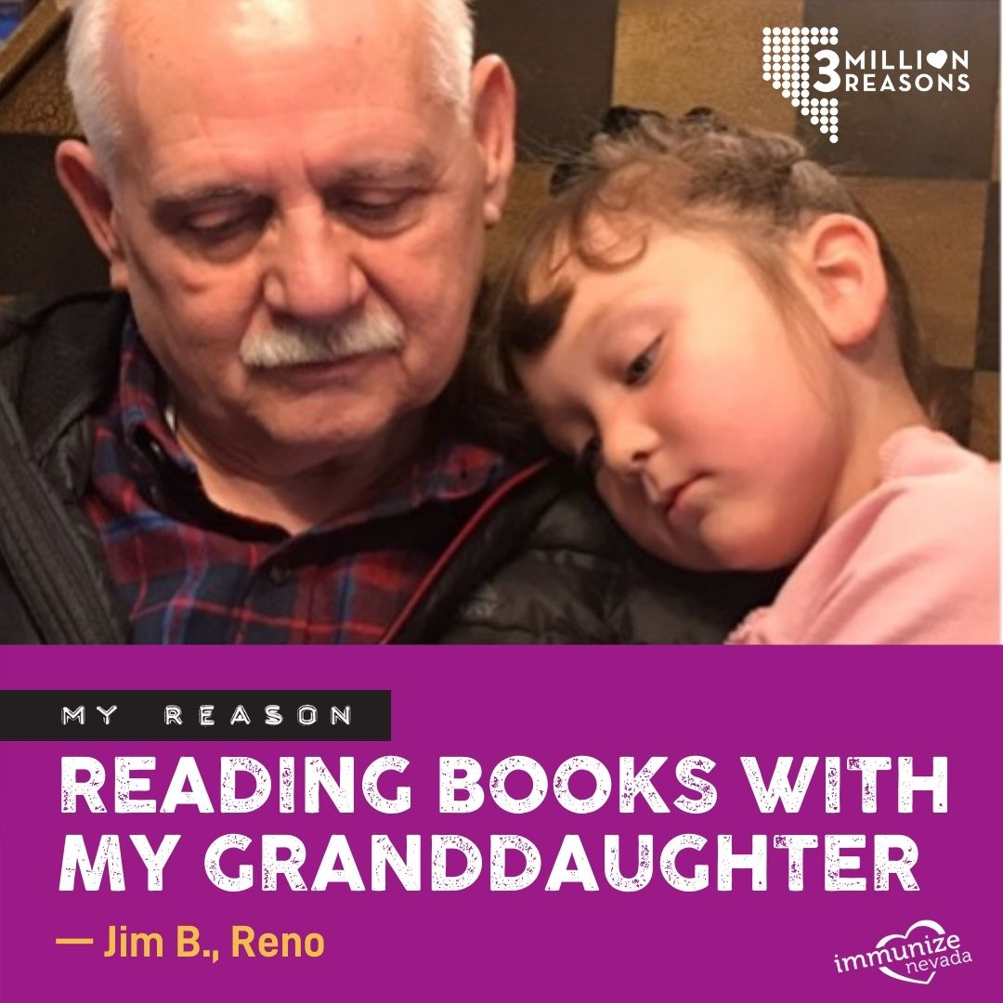

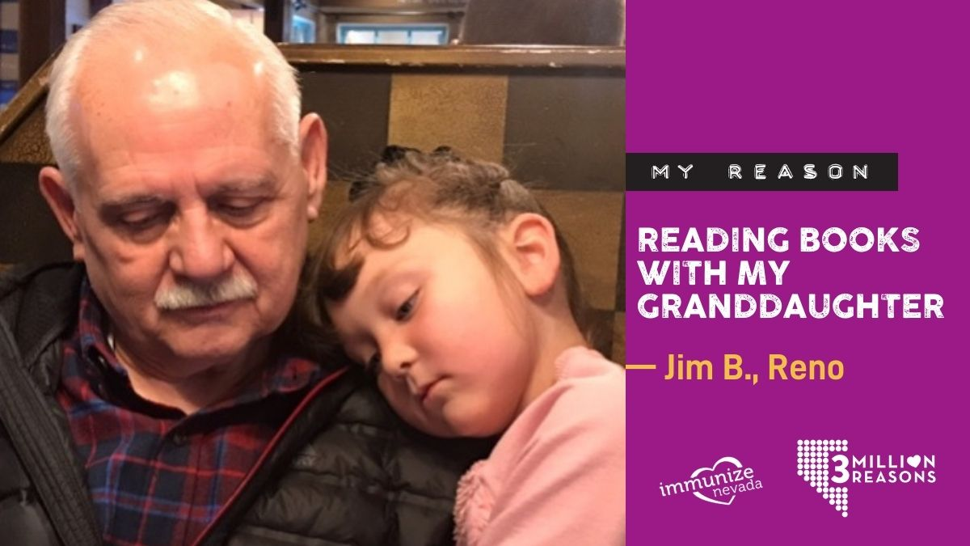
TW

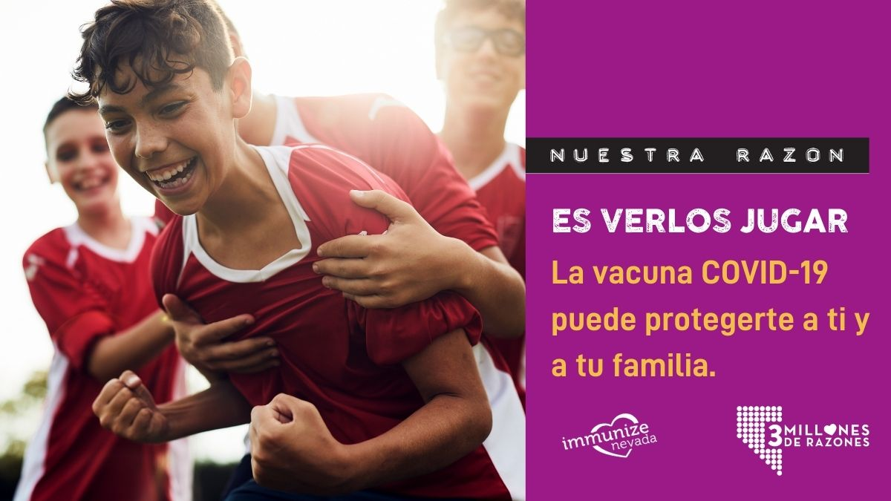

Caption:
Everyone has a reason for getting their COVID-19 vaccine — what’s yours? Get vaccinated against COVID-19 today and protect yourself. For more information about how to get vaccinated, visit nvcovidfighter.org. #3millionreasons #everynevdancounts

Todos tenemos nuestras razones para esperar la protección contra el COVID-19. ¿Cuál es la tuya? Vacúnate hoy contra el COVID-19 y protégete. para más información sobre cómo vacunarse, visite nvcovidfighter.org. #3millonesderazones

FB/IG
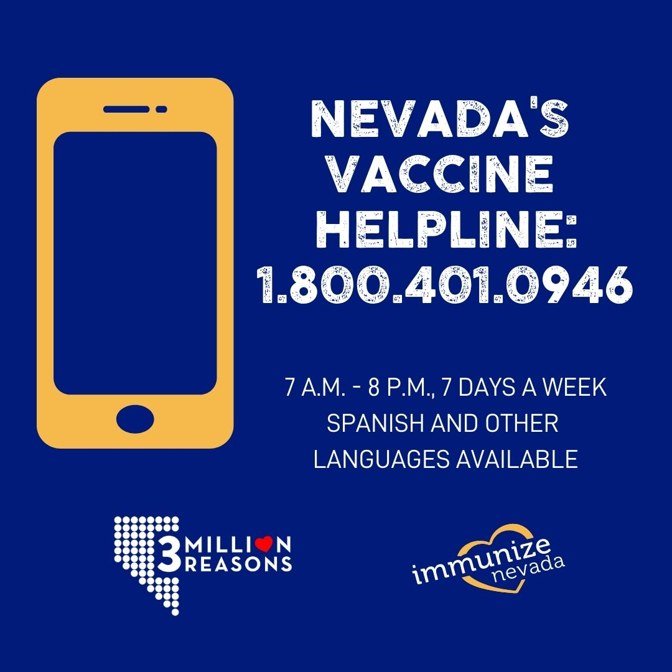

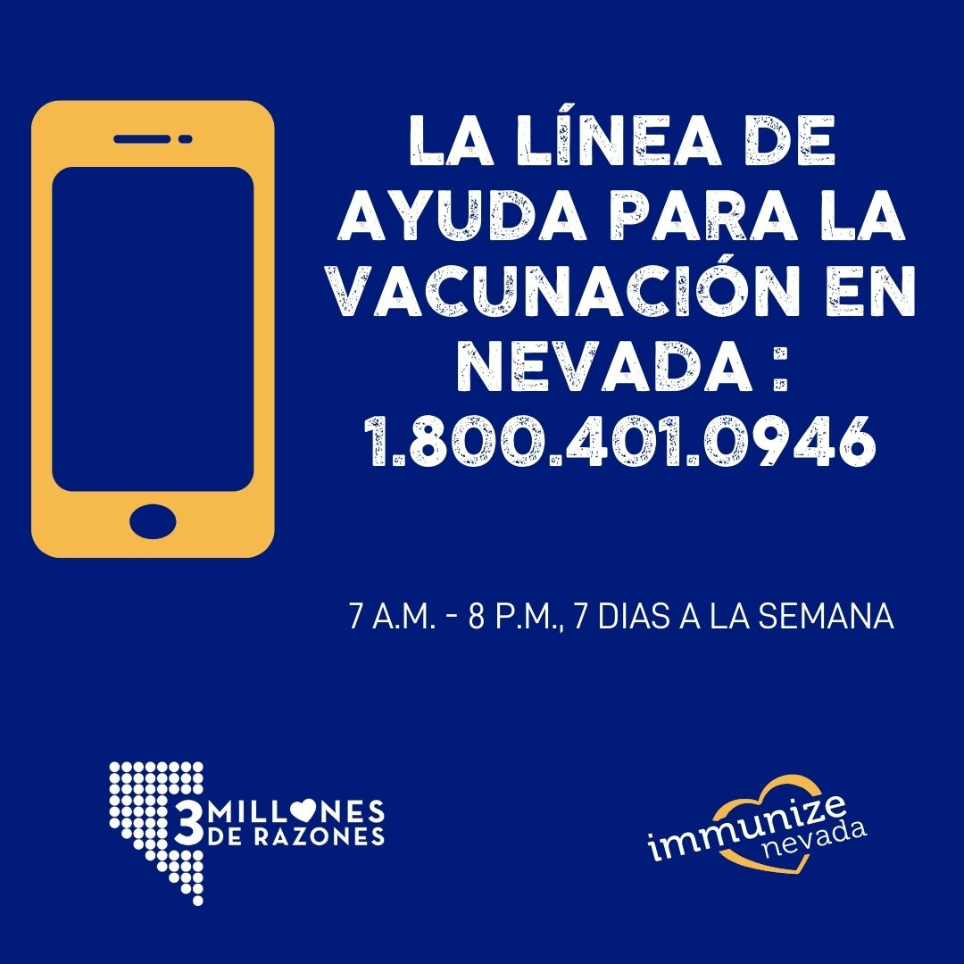

TW
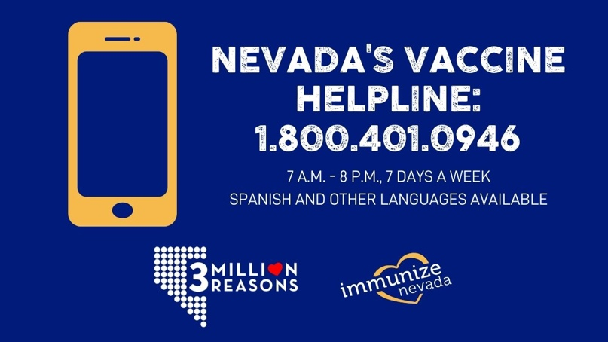

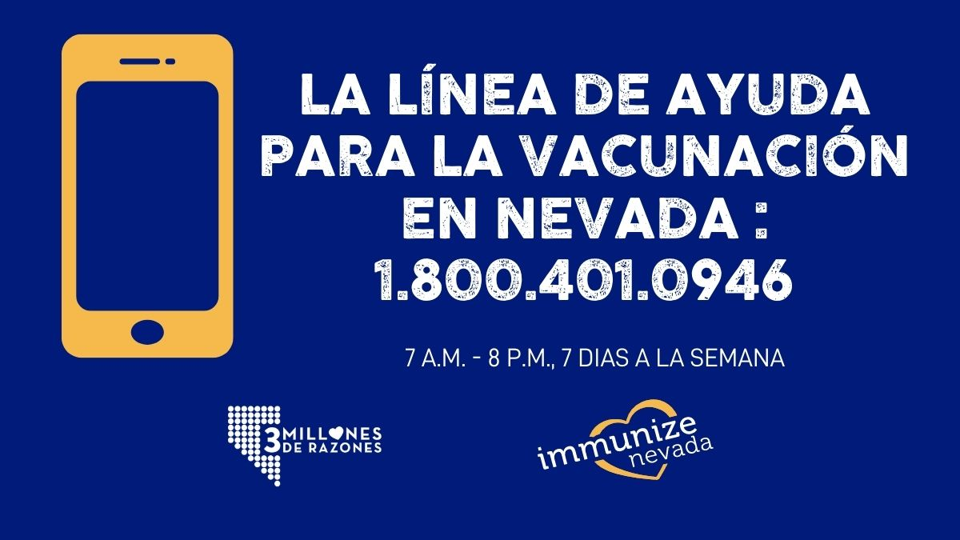

Caption:
Nevada's Vaccine Helpline is available for anyone seeking to speak with a person about vaccine eligibility and locations. Call Center staff speak English and Spanish and have access to the language line for other languages as needed. #3millionreasons

La Línea de Ayuda para la Vacunación está disponible para todos los que requieran hablar con alguien sobre las vacunas COVID-19. El equipo de Atención al Cliente habla inglés y español y tiene una línea especial para cubrir tus necesidades en otros idiomas. #3millonesderazones

FB/IG
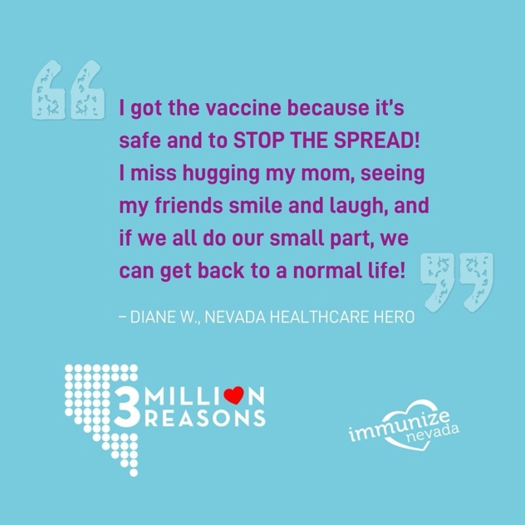

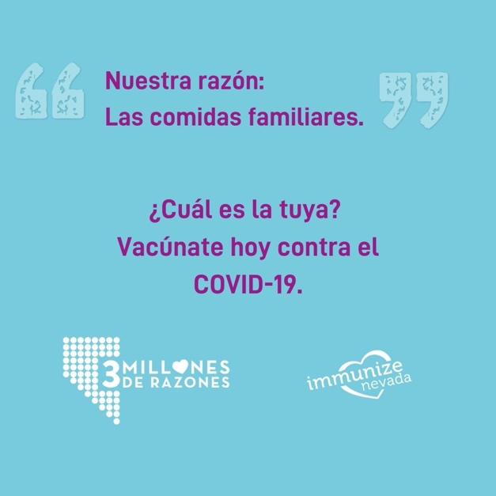
TW
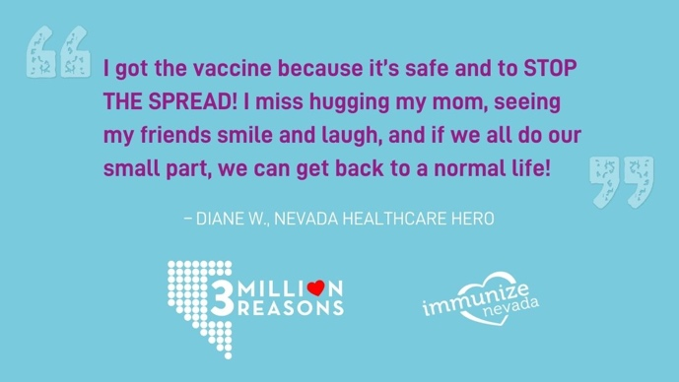

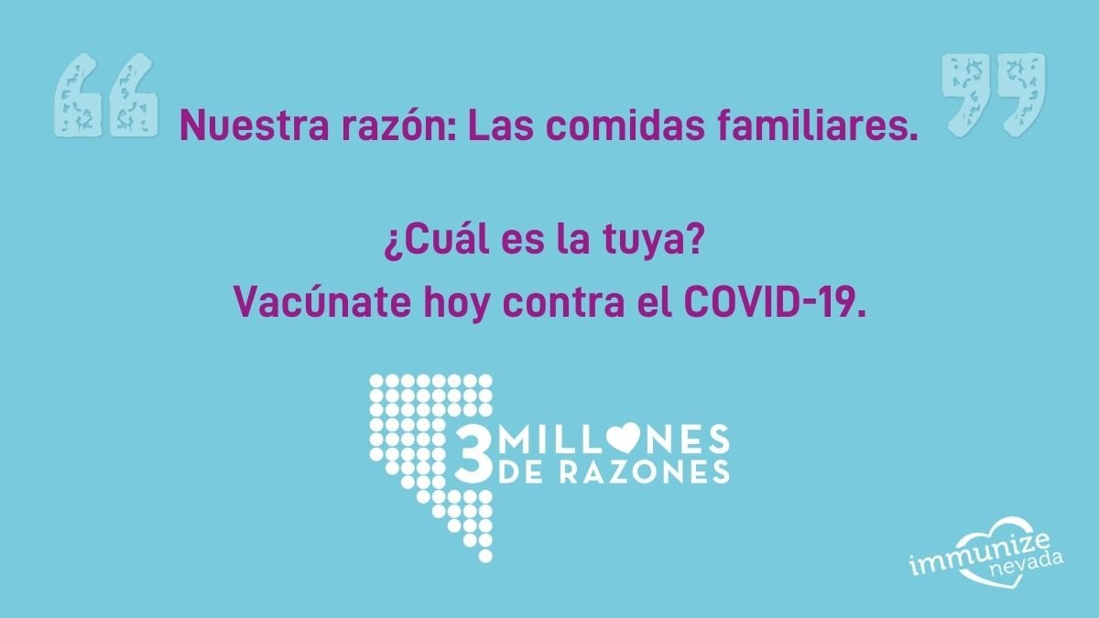

Caption:
We all want to get back to doing what we love. COVID-19 vaccination is how we’ll get there. Get answers to your questions so you can get protected. For more information about how to get vaccinated, visit nvcovidfighter.org. #3millionreasons

Todos queremos volver a hacer lo que más nos gusta. La vacuna COVID-19 es la respuesta.
Obtenga respuestas a sus dudas y empiece a protegerse. Para más información sobre cómo vacunarse, visite nvcovidfighter.org. #3millonesderazones
FB/IG
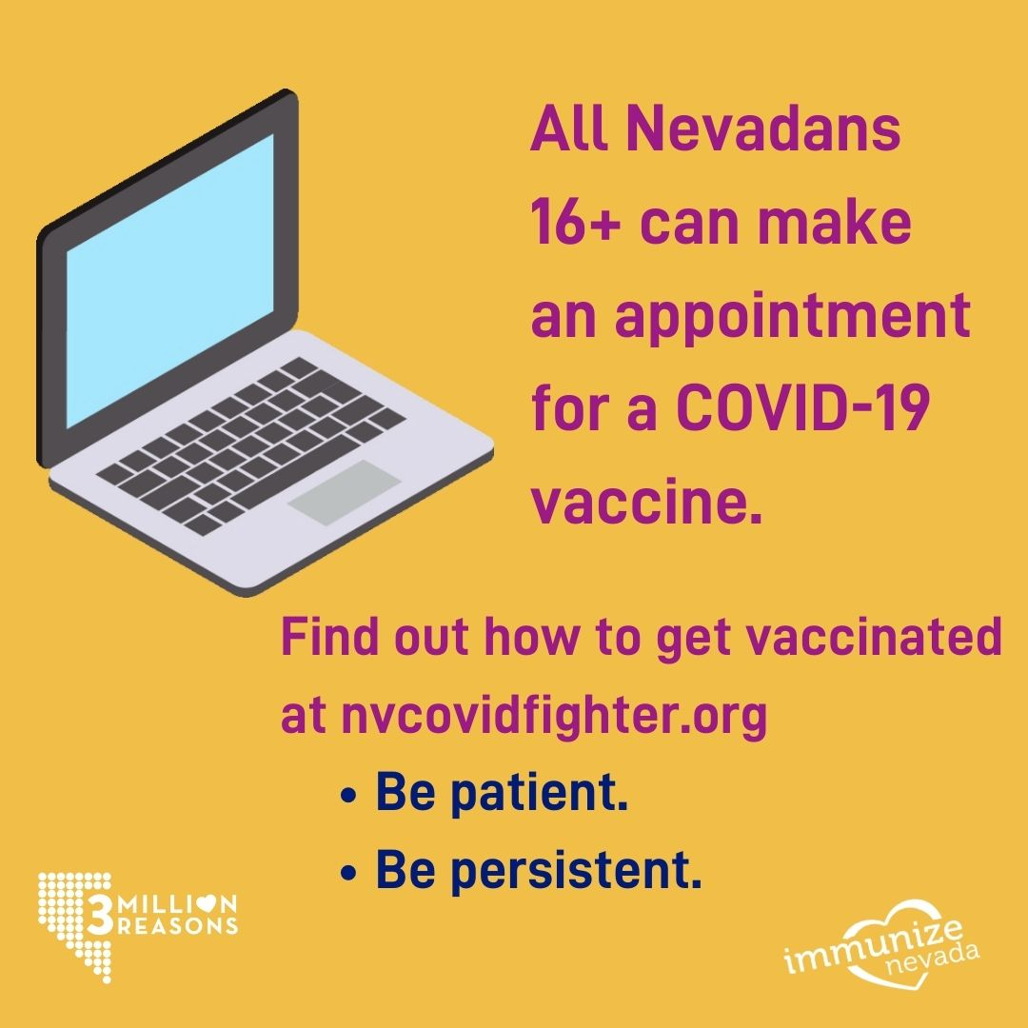

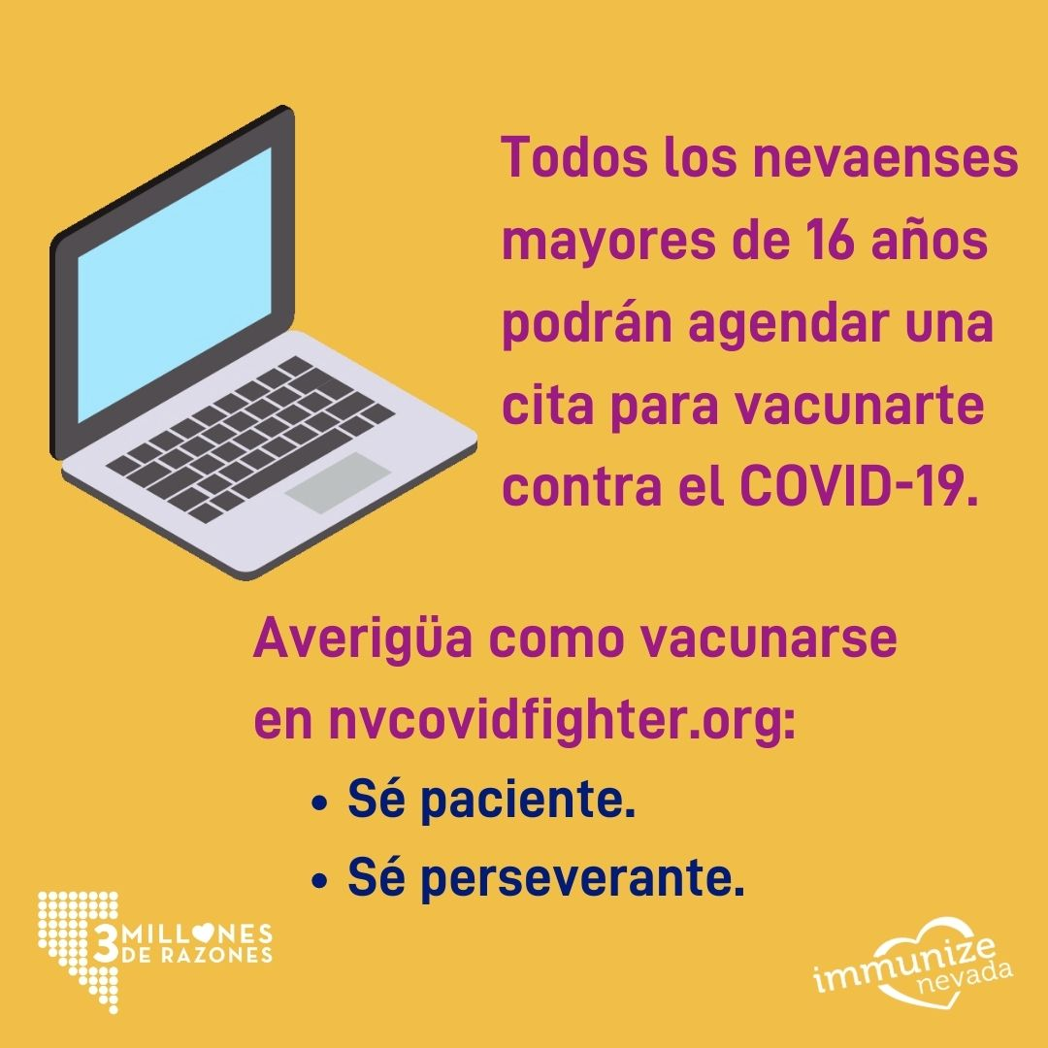

TW
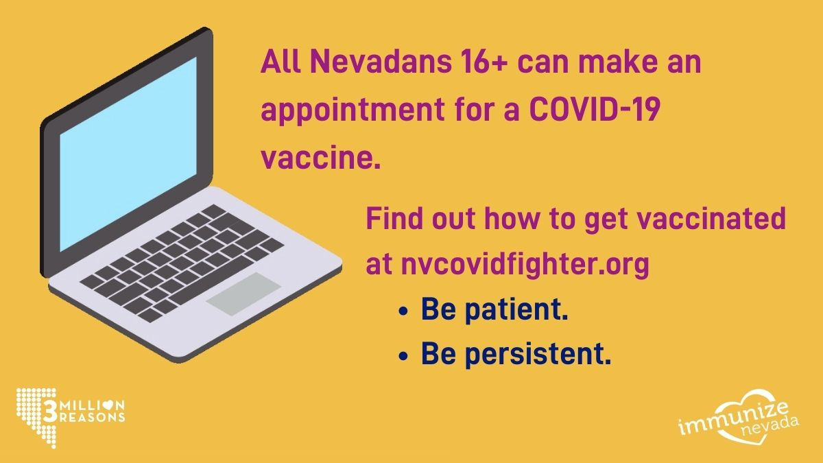

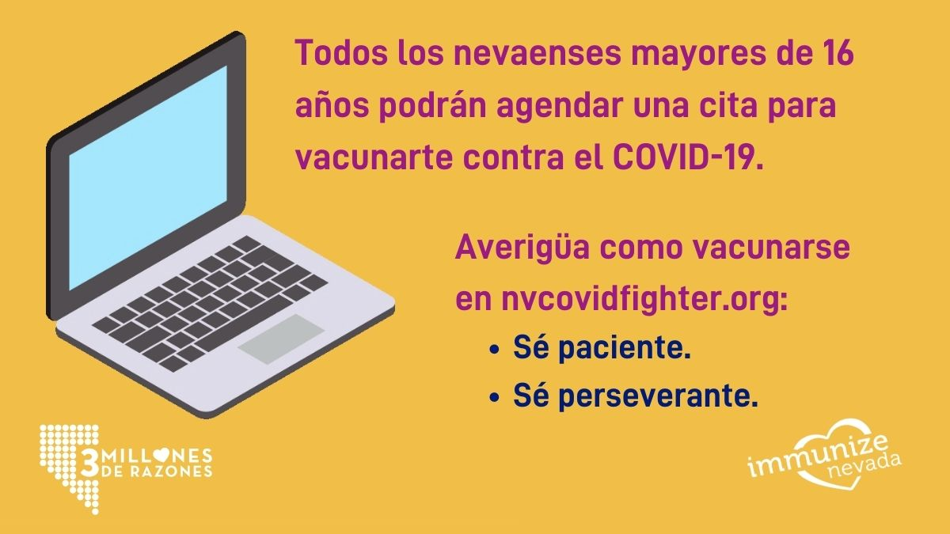

Caption:
Appointments for COVID-19 vaccines open up when doses become available, so please keep checking back for open appointments. Find the vaccine location closest to you at nvcovidfighter.org. #3millionreasons
Las citas para las vacunas COVID-19 se abren cuando las dosis están disponibles, así que, por favor, sigue revisando continuamente. Busca el centro de vacunación más cercano en nvcovidfighter.org. #3millonesderazones

FB/IG
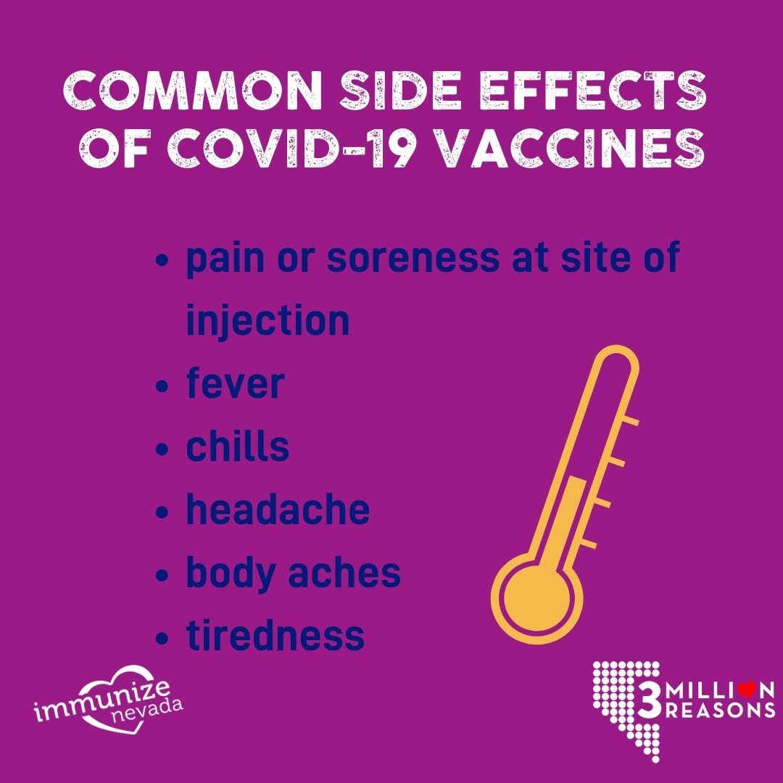

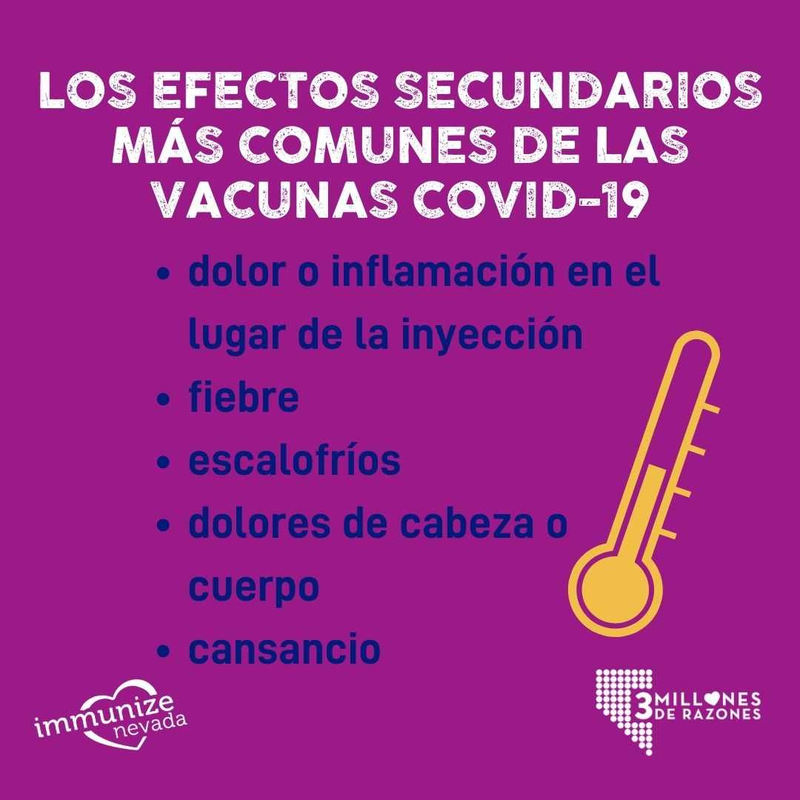

TW
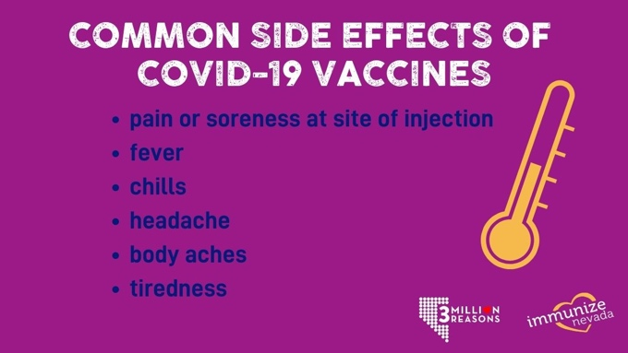

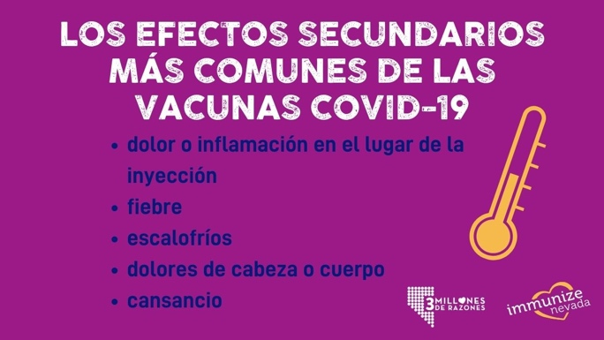

Caption:
Some people have minor side effects after COVID-19 vaccination, and some don’t. Side effects are temporary — most go away within 24-48 hours — and may feel like flu, including aches, fever and chills. Also, expect some soreness at the site of the injection. Whether or not you experience side effects, your body is hard at work building protection against COVID-19. #3millionreasons

Algunas personas tienen efectos secundarios leves después de recibir la vacuna COVID-19, otros no. Los efectos son temporales; la mayoría se eliminan dentro de las primeras 24 a 48 horas y pueden presentarse como gripe, incluyendo dolores y/o malestares, fiebre y escalofríos. Además, puedes sentir dolor en el lugar de la inyección. Así que experimentes o no los efectos secundarios, recuerda que tu cuerpo está generando protección contra el COVID-19. #3millonesderazones

Twitter Caption:
Some have minor side effects after COVID-19 vaccination, and some don’t. Most go away within 24-48 hours and may feel like flu. Also, expect some pain at the site of the injection. Whether or not you experience side effects, your body is hard at work building protection.

Algunas personas tienen efectos secundarios leves después de recibir la vacuna COVID-19, otros no. Los efectos son temporales; la mayoría se eliminan dentro de las primeras 24 a 48 horas y pueden presentarse como gripe.

FB/IG
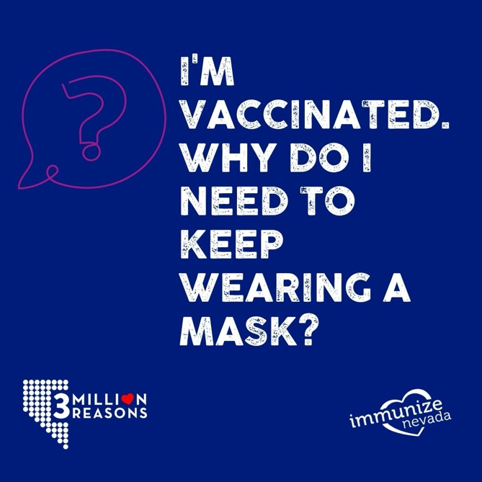

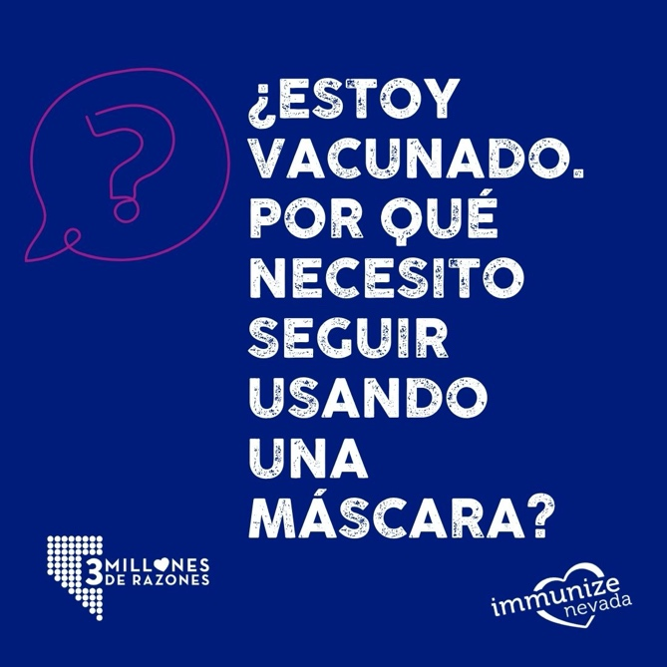

TW
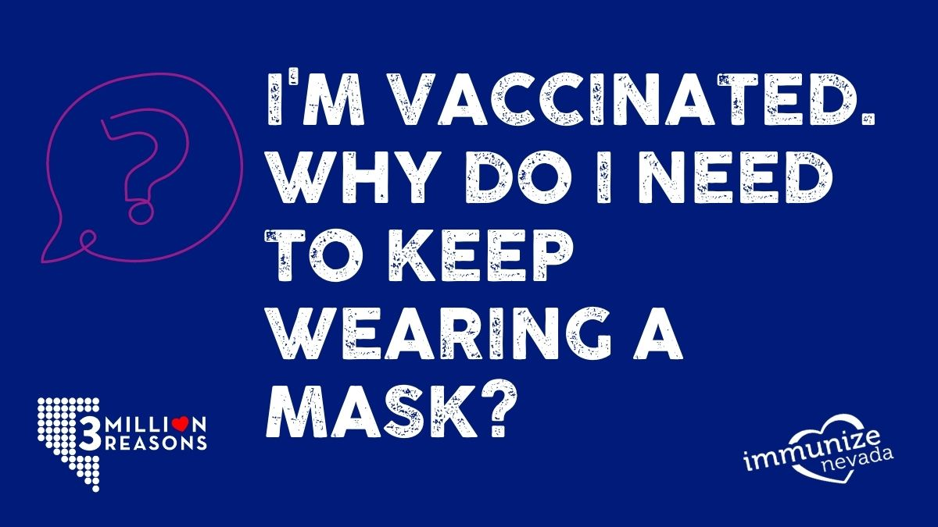

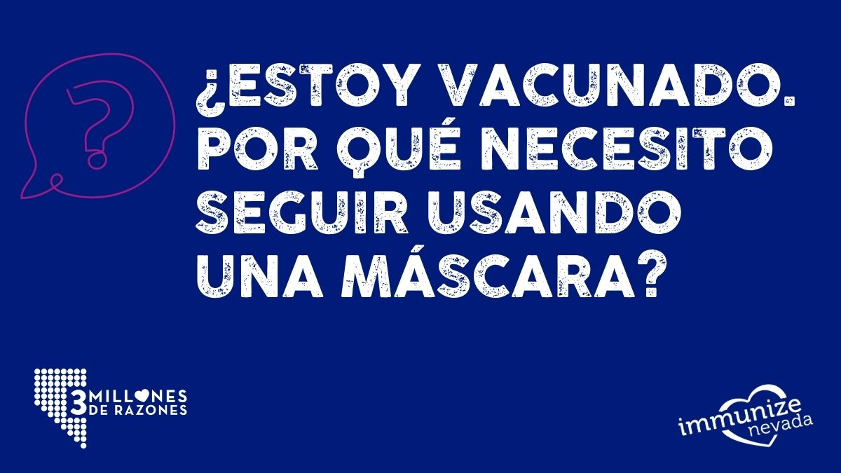

Caption:
You have questions about COVID-19 vaccines, and that’s totally understandable. Get answers to your questions, and learn how a COVID-19 vaccine can protect you and your family at nvcovidfighter.org. What’s your reason for wanting protection from COVID-19? #3millionreasons

Sabemos que tienes preguntas sobre las vacunas COVID-19 y eso lo entendemos perfectamente. Obtenga respuestas a sus preguntas, y aprenda cómo la vacuna COVID-19 puede protegerlo a usted y a su familia, en nvcovidfighter.org. ¿Cuál es su razón? #3millonesderazones
FB/IG
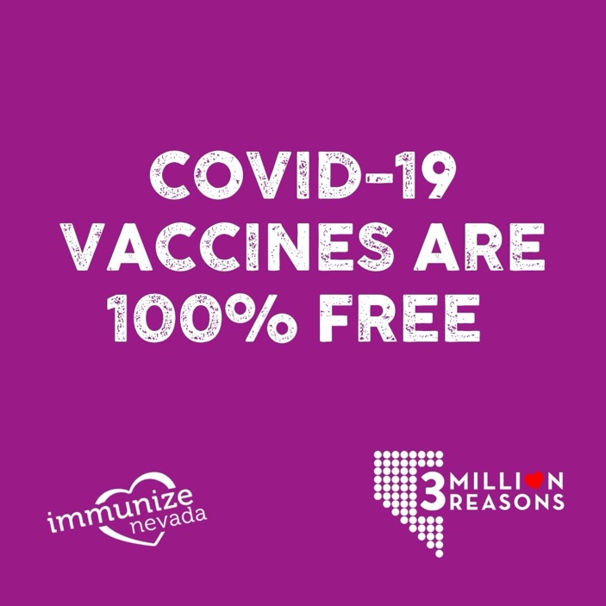

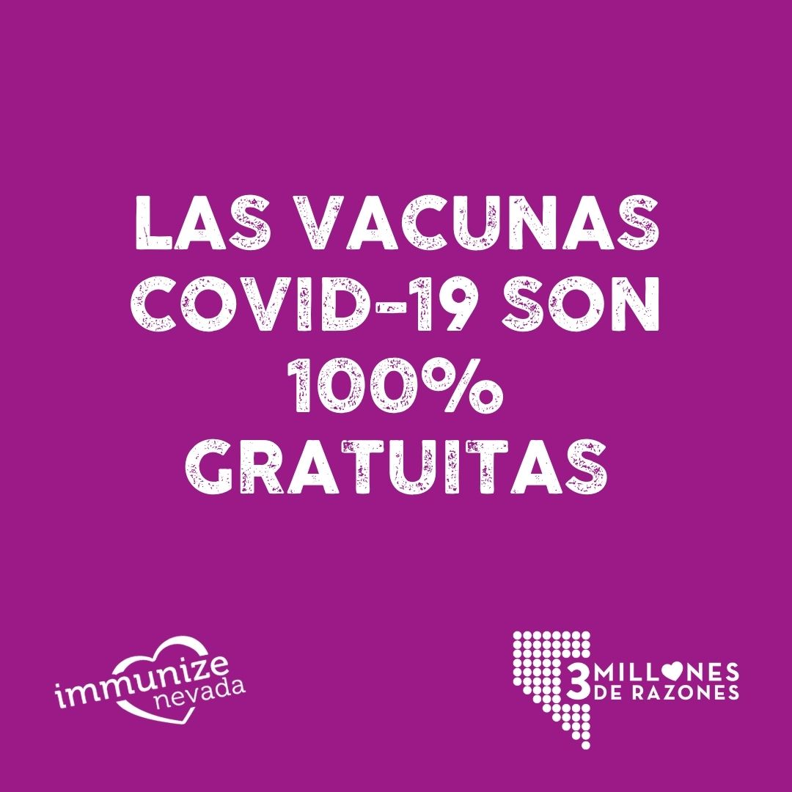

TW
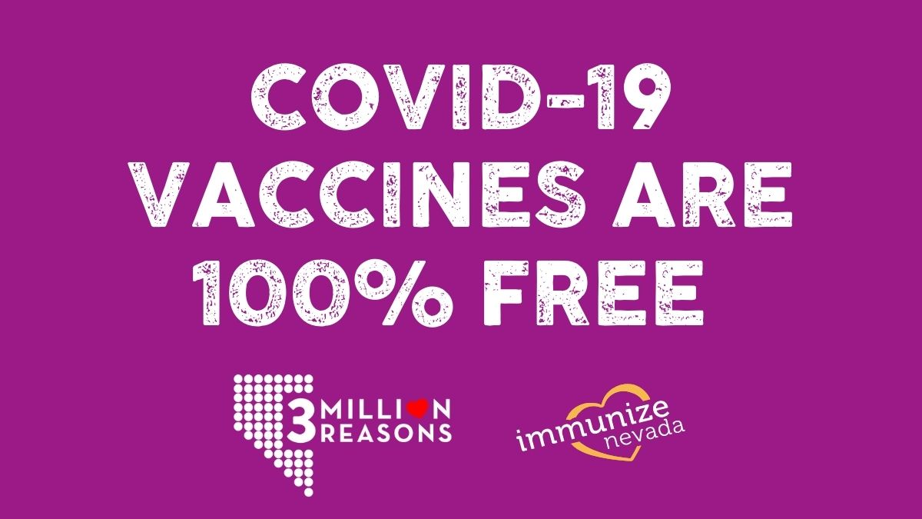

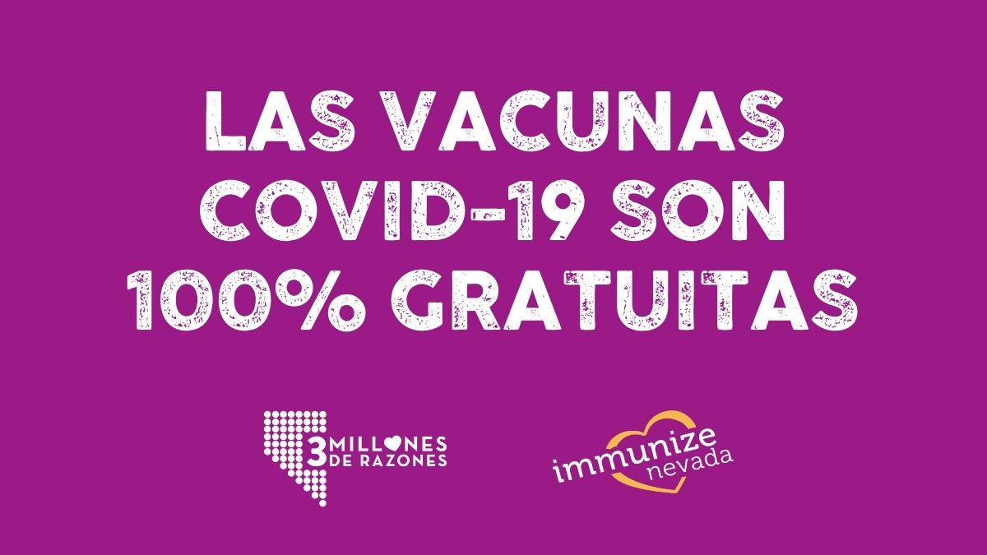

Caption:
COVID-19 vaccines are free, whether or not you have health insurance. Find more answers to your vaccine questions at nvcovidfighter.org. Nevada has #3millionreasons to unify behind these life-saving vaccines — and you’re one of them. #everynevadancounts

Las vacunas son GRATUITAS, ya sea que se cuente con seguro médico o no.
Sabemos que tienes preguntas sobre las vacunas COVID-19. Obtenga respuestas a sus dudas en nvcovidfighter.org. #3millonesderazones

